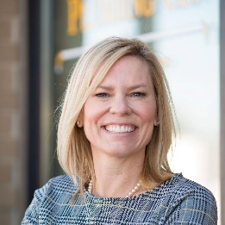
SPEAKER BIOS
Shawn Erickson, CCIFP, MBA
CFO, C.J. Erickson Plumbing Co.
Shawn, CFO of C.J. Erickson Plumbing Co., a commercial plumbing and site utility contractor in Chicagoland. Shawn joined her husband’s 4th generation family business in 1998 after working in public accounting and private industry. She holds an accounting degree from Michigan State University and an MBA from Keller Graduate school. She joined CFMA in 1999 and has served the Chicago Chapter as Chapter President, Board member and various Committee Chairs over the last 25 years. She is still very active in her chapter serving in various capacities where needed. At National, Shawn has been a member of the Executive Committee, the Conference Planning Taskforce and various other committees. Shawn is currently the Chair of the National Subspecialty Committee and a member of the Leadership Development Committee. Shawn is a proud recipient of the 2017 Joe Quigley Award.
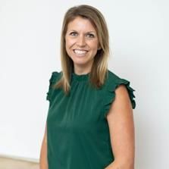
Jessica Krause, CCIFP
Owner, New Lyfe Accounting

Jessica’s passion for the construction industry stems from its place in her childhood, growing up in the family sheet metal business. Her career began in public accounting before she eventually became CFO for a Commercial Electrical Contractor based in Kansas City. While in that position, she realized the need for a specialized accounting firm within construction – one that understood the industry’s complexities, processes, and people. From that discovery, founded her firm, New Lyfe Accounting in 2017. Jessica holds a Masters of Science in Accounting degree from the University of Missouri - Kansas City. She has been a Certified Public Accountant for 15 years. Jessica also has a CCIFP designation and has been a member of CFMA since 2013. She is currently an active member of the Specialty Trade Committee of CFMA.

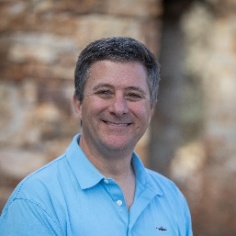
Dan White, CCIFP
CFO, Gallegos Corporation
Dan White grew up in the Denver metropolitan area where he graduated from Metropolitan State University of Denver with a BS in Accounting. He worked for 10 years for a regional CPA firm in Denver before moving to the Vail Valley in 2006. Dan is the CFO for the Gallegos Corporation, a regional marble and granite, masonry, and concrete specialty subcontractor with annual volume ranging from $35M - $50M per year and an average of 250 employees. Dan is a CCIFP and has been a member of CFMA since 2015. Dan lives in Gypsum with his wife Monica and their daughter Sage who all enjoy skiing, rafting, hiking, and camping.

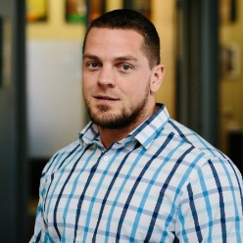
Mike Megara
CFO, Weifield Group Holdings
As CFO of Weifield Group Holdings and three Operating Subsidiaries (located in RM region, TX and TN), Mike provides leadership and direction for the accounting, finance, risk management/legal and IT support services divisions of the company from the home office in Centennial Colorado. He started his construction career 15 years ago on the operations side of the business as a PM and moved to Accounting/finance as the need presented itself due to growth. He has in his CFO role been part of a few special projects; including multiple system implementations/conversions, M&A, and Captive insurance programs. Mike holds an undergraduate degree in Business Management from SUNY Stony Brook and a MBA from the University of Phoenix. Prior to his financial career, Mike served four years in the Marine Corps.

