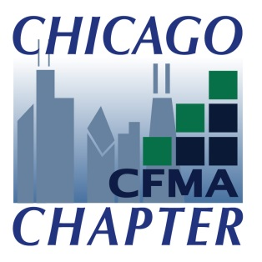
2021 “Build Chicago” Awards
Program Ad Copy Form
To reserve space, complete this form and scan/email to dhypke@managementservices.org. Completed ad copy does not need to be submitted with the form but ads are due by 10/29/21.
Please send ad copy directly to Deb Hypke at the same email.
Company Name:
Contact:
Phone:
E-mail:
Billing Information: Payment submitted online at Chicago.cfma.org
Please email an invoice
Please call me to process a credit card over the phone
Ad Copy Deadline: October 29, 2021 at 12:00 p.m.
Select an Ad Size:
___ Full Page Ad $400 ___ ½ Page Ad $250
___ Annual Sponsor Ad Upgrade $150 (change from a ½ page to a full page)
Camera Ready Art and Design Specifications:
Logo: Optimal quality is 300 dpi, full-color in EPS format. If EPS is not available, we will accept 300 dpi, color JPG, TIF or a high resolution PDF.
Dimensions: Full Page: 4.5” wide x 7.25” high
Half Page: 4.5” wide x 3.5” high
Special Instructions:
Questions regarding ad requirements or for assistance with design layout, please contact Deb Hypke at 815-806-4908.

